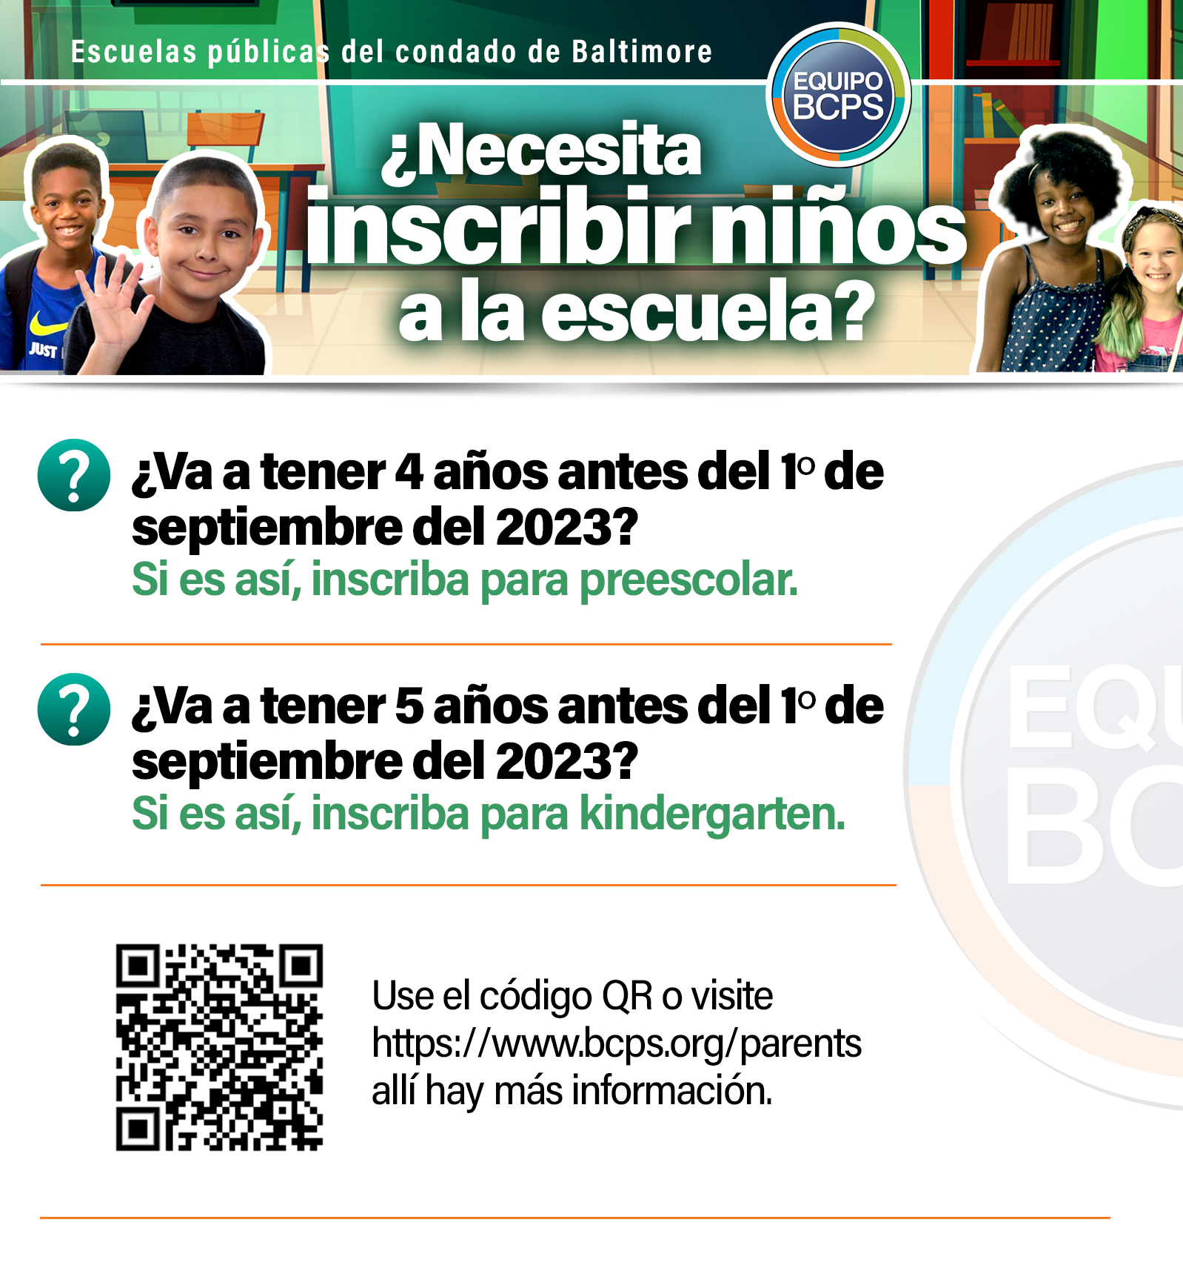
SEVEN OAKS ELEMENTARY SCHOOL
9220 Seven Courts Drive
Baltimore, MD 21236
Phone: 443-809-6257 | Fax: 443-809-5144

